Linux Operating system

Linux:
- Linux is a free and Open-source operating system with high security. Linux is multiuser based OS.

Operating system:
An Operating System (OS) is a software that acts as an interface between computer hardware components and the user.
Every computer system must have at least one operating system to run other programs. Applications like Browsers, MS Office, Notepad Games, etc., need some environment to run and perform its tasks.

Linux OS Distributions:
- RedHat
- Ubuntu
- Debian
- Centos
- Fedora
- OpenSUSE
- Kali Linux
- Amazon Linux
- Rocky Linux

ARCHITECTURE:

KERNEL:
- manages the Hardware Components. CPU, memory, and peripheral devices. The kernel is the lowest level of the OS.
- It is the core or the heart of the operating system. It's the central part that manages and facilitates communication between the computer's hardware and software.

DAEMONS: Manages are background services (printing, sound, scheduling, etc.) that either start up during boot or after you log into the desktop.

SHELL:
- Manages are background services (printing, sound, scheduling, etc.) that either start up during boot or after you log into the desktop. A shell that allows users to interact with the operating system. There are two types of shells.
. Command Line Interface (CLI): Executes the command provided by user given in the form command and display the output in terminal.
. Executes the process provided by user in graphical way and output is displayed in the graphical window.
COMMAND:
- It is an instruction/request given to the operating system by a user.
- It tells computer to perform a particular task.
TERMINAL:
- It is a text-based interface that allows you to interact with the operating system by typing commands.
- It's a way for you to communicate with the Linux machines.

- In Linux we have different types of commands
- SYSTEM COMMANDS
- HARDWARE COMMANDS
- FILE COMMANDS
- PERMISSION COMMANDS
- USER COMMANDS
- SEARCH COMMANDS
- NETWORKING COMMANDS
- These commands are used in Linux operating system to perform different actions.

Linux commands:

touch command: used to create a file.
ls command: used to check the list of files.
Whoami command: used to check the which directory.
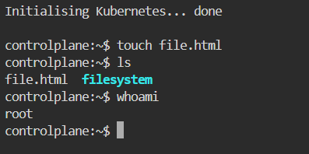
.
vi command: This command directly creates and open the file.
But, in this file we cannot write anything directly. So, there are some shortcuts.
Enter ‘I’ in keyboard to insert the text.
Enter ‘Esc’ button to exit from insert mode.
Enter ‘: wq’ for save and exit.
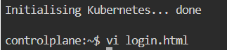
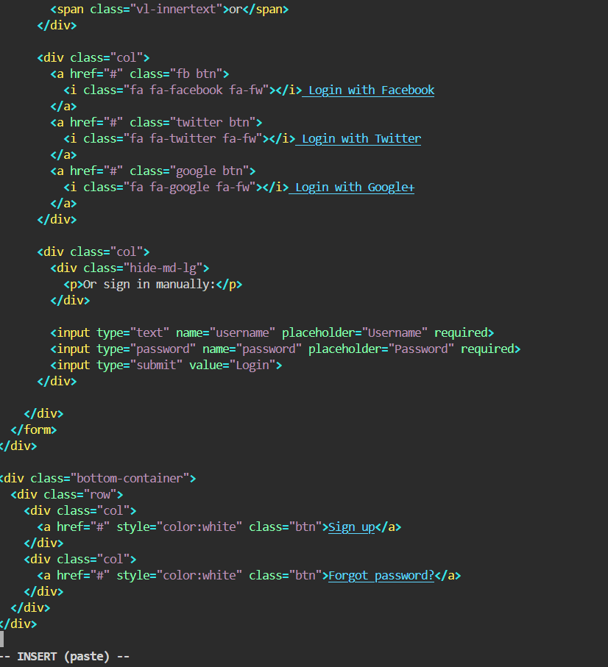
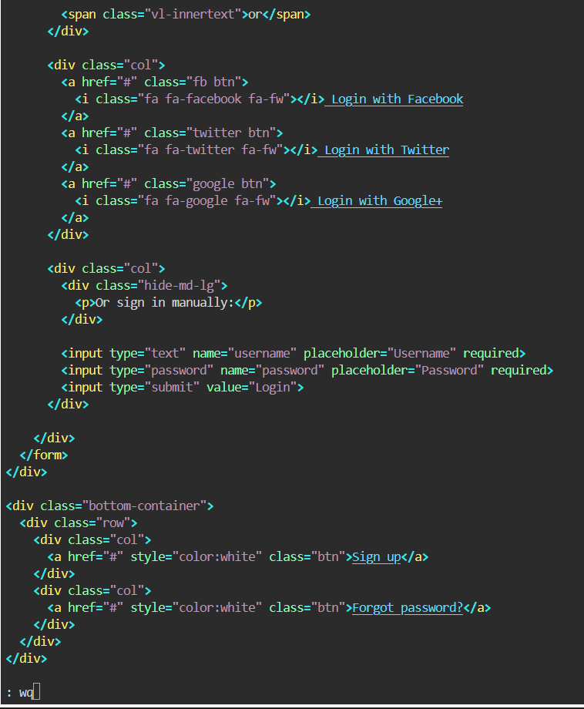
cat command: It is used to view the information that already exists in file.
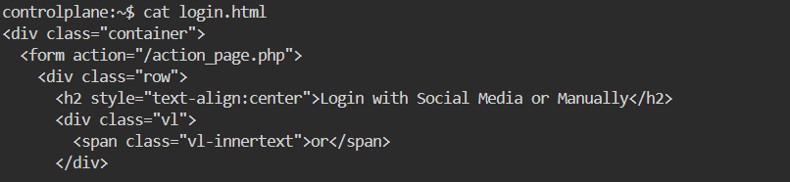

nano command: This command is for we can directly insert the information without any shortcut (like ‘I’ in keyboard).
But there are some shortcuts to save the file.
Enter ‘ctrl+x’ in keyboard to save options.
Enter ‘ctrl+y’ in keyboard to select yes and then ‘Enter’ button to exit.
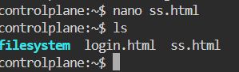
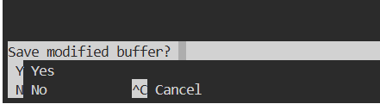

rm command: It is used to remove only one file at once.
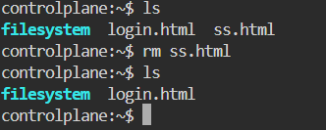

mkdir command: To create the new directory.
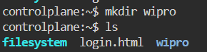

cd command: To go to the root directory.
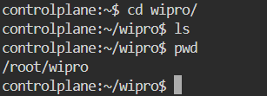

pwd command: used to check the which directory we are in present.

cd .. command: used to go back to the main directory.
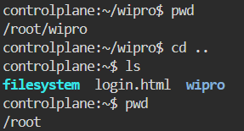

mv command: we use this command in two cases.
Case I: To change the name of the file.
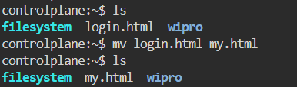
Case II: to move the file.
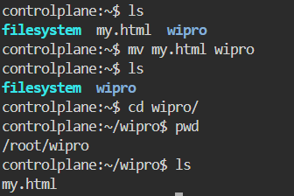
rmdir command: to remove the empty directory only.
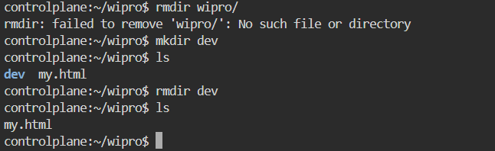

rm -rf command: used to remove the directory.
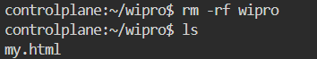

wget command: used to install any application via link.
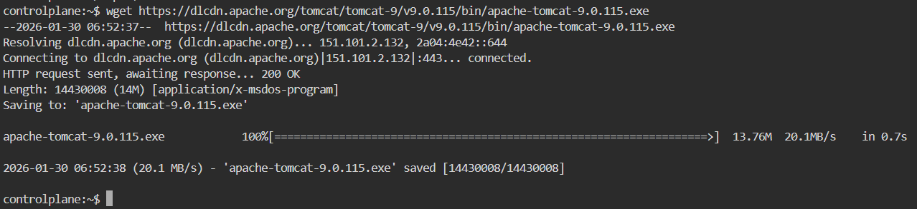

ping command: used to diagnoses network issues and confirms if a server is online or a network path is active.
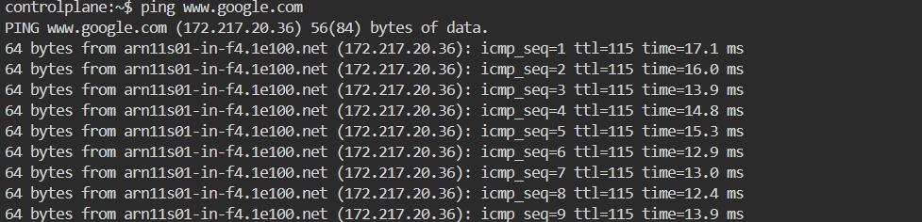

history command: to see all used commands in that editor.
